“Belonging Begins With Us” – Influencer/Content Creator Brief
CAMPAIGN OVERVIEW
We all know what it feels like to feel left out – to feel like we don’t belong. And for people who have moved to this country, that experience can last more than a moment. We can change that.
The Ad Council, in partnership with a coalition of public and private partners who work across American communities (including the American Alliance of Museums, the Council for Christian Colleges & Universities, the YMCA of the USA, Trust for Public Land, American Immigration Council, Welcoming America and more), has recently announced a new national campaign to help create a more welcoming nation where everyone can feel like they belong.
The campaign is designed to reach the 40% of Americans who are conflicted on a number of social and political issues, who often feel overlooked in a media environment that plays to extreme viewpoints.
“Belonging Begins With Us” is a movement dedicated to changing the conversation about who gets to feel like they belong in the United States, with the end goal of making all communities more welcoming places. We hope you’ll join us in sharing this message that we all have the power to make others feel like they belong.
CAMPAIGN GOALS
- Primary goal: Drive awareness of the #BelongingBeginsWithUs campaign and its message of creating more welcoming communities – for everyone
- Secondary goal: Drive to the website at BelongingBeginsWithUs.org. There, people can find stories of belonging from all across the country, and actions to take to help others in their community feel that they belong.
CALL TO ACTION
- We’ve all had moments of feeling left out. And for people who move to this country, that feeling lasts more than a moment. We can change that. Belonging Begins With Us.
CREATIVE SUGGESTIONS
Suggested Platforms: YouTube, TikTok, Instagram videos
- IDEA 1: Belonging Begins with Me
  - Create a vlog showing your audience how you show up for your community. Have you ever interacted with a new neighbor? How do you help newcomers in your community feel like they belong?
Examples can include setting up a text thread with your neighbors to stay connected, joining a dog walking group and get to know other dog owners in your community, or sending a note to a new neighbor or colleague asking to connect remotely for coffee.
Then, “pass the baton” and encourage your audience to think about ways they can help make their community more welcoming – for everyone.
    - For inspiration, check out stories of belonging at https://belongingbeginswithus.org/
- IDEA 2: When I Feel Included
  - Create a video talking about a time you felt included or a time you felt excluded and how that experience impacted you. Maybe you moved to a new town and started school as the new kid. Maybe as an adult you were the only person of your background to join a certain club, group or activity.
What did people in your community do to help you acclimate? What were some actions that you specifically remembered or admired?
If relevant, talk about specific local organizations that helped you feel like you belonged – like libraries, sports clubs, or non-profits. Then, “pass the baton” and encourage your audience to think about ways they can help make their community more welcoming— for everyone.
    - For inspiration, check out stories of belonging at https://belongingbeginswithus.org/
Suggested Platforms: Instagram Feed + Stories, Facebook Feed + Stories, Twitter Feed + Fleets
- Idea 3: Photo + Story Series:
  - Share a photo or carousel of your own photos illustrating one of the prompts above, and tell the story in the caption (rather than a vlog.)
  - Share in a Facebook/Instagram stories series as well, leveraging features like Polls, Questions, Stickers, Quizzes or other interactive elements to engage your followers.
  - If this is for stories, please add this to your highlights so it is ongoing promotion.
TALKING POINTS
- We’ve all had moments where we felt like we didn’t belong. But for people who moved to this country, this experience can last more than a moment. Belonging Begins With Us is a new, fully integrated campaign dedicated to fostering a more welcoming nation where everyone – regardless of their background or where they were born – can feel they belong.
- When we welcome and include everyone who calls America home, we bring out the best in our nation and in ourselves.
- Each of us has the power to make our neighborhoods, workplaces and schools more welcoming.
- Visit BelongingBeginsWithUs.org to read real stories of welcoming and belonging from across the country, and find ways to get involved in your own community.
- (Note: instead of using the term “immigrant” please use the term “people who moved to this country”)

SHAREABLE CONTENT
- Twitter: https://twitter.com/AdCouncil/status/1334502456185774084
- Facebook: https://www.facebook.com/watch/?v=249901226492076
- Instagram: https://www.instagram.com/p/CIVqX0yDZVO/
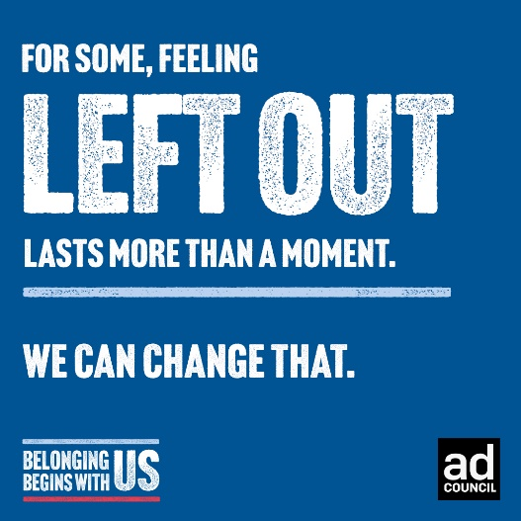
(*Note – Instagram posts from someone else’s handle can only be shared to your stories, not your feed. In addition to sharing to your stories you may also want post a static image to your feed, such as the graphic shown here. Additional assets available for download here.)

SUGGESTED COPY
- It’s up to each of us to make our neighborhoods, workplaces and schools more welcoming for everyone, no matter who they are or where they were born. How do you help others in your community feel like they belong? #BelongingBeginsWithUs

- #BelongingBeginsWithUs means we ALL have the power to help others feel welcome in our communities and in our country. How can you help others feel like they belong?

- We’ve all had moments when we felt like we didn’t belong, but for people who moved to this country, that feeling can last more than a moment. We can change that. I’m committing to making everyone feel welcome– will you join me? #BelongingBeginsWithUs
WEBSITE: https://belongingbeginswithus.org
HASHTAG: #BelongingBeginsWithUs
HANDLES TO TAG: @adcouncil

