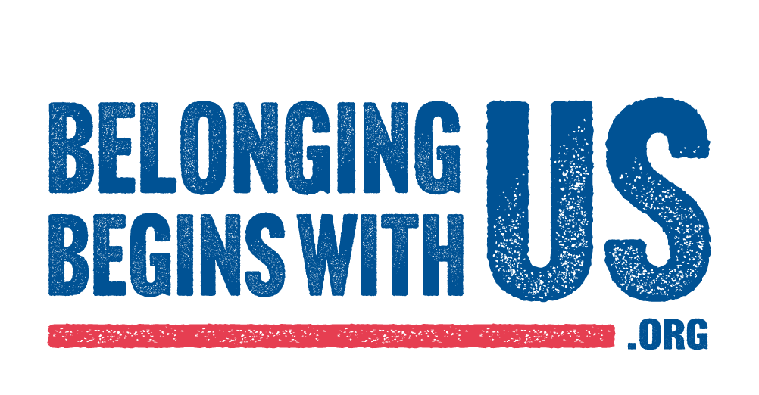

SAMPLE PSA DIRECTOR LETTER

Your corporate logo/header

Date
Name
Title
Station/Media Name
Street Address
City, State, Zip Code

Dear (Personalize for each Public Service Director):

I’m reaching out to tell you about the new Belonging Begins With Us PSA campaign from the Ad Council. Belonging Begins With Us is an integrated, multi-year communications campaign with the goal of fostering a more welcoming nation where everyone can belong. The campaign creative sums it up best: We’ve all had moments of feeling left out. And for people who move to this country, that feeling lasts more than a moment. We can change that. #BelongingBeginsWithUs

The PSAs are designed to build empathy among neighbors and introduce new ways to think about people who move to this country. To create momentum and provide opportunities for engagement and education, the PSAs will drive to BelongingBeginsWithUs.org. This website is an extensive resource which includes stories across America of belonging as well as tips for how individuals and communities can become more welcoming.

We ask you to help support the campaign by airing the Belonging Begins With Us PSAs that you received. Additionally, the campaign materials can be downloaded from the Ad Council’s website. The campaign materials include TV, radio, digital media, outdoor and print, all of which direct to BelongingBeginsWithUs.org. By airing the PSAs you are helping us to increase awareness, educate, and ultimately affect behavior change for the betterment of our nation. Thank you for your time and support!

Sincerely,
Name
Title
Company/Organization

